**Department of Computer Systems Engineering**

**University of Engineering & Technology**

**Peshawar, Pakistan**

**Communications Systems (Final Term Exam), Fall 2020**

Time Allowed: 03 Hours, Total Marks: 100, Weightage: 25%

**Instructions:**

* Attempt all questions, ALL questions carry equal marks.
* Read the complete paper in the first 15 minutes and get your queries (if any) clarified within this time; No question will be entertained after this time. Moreover, if you feel any data missing, you can assume any reasonable values for it.

1. Discuss the bandwidth of rect (t/τ) for τ = 0.5 µsec, τ = 1 µsec and τ = 2 µsec.
2. What do you mean by scaling property? Discuss the significance of the scaling property.
3. Describe Time-Shifting property and its physical explanation.
4. Explore modulated signal g(t)cos ω0t in the frequency domain. Proof the shift of band with the aid of mathematical expressions.
5. Explain signal transmission through a linear system, signal distortion during transmission, distortion less transmission and intuitive explanation of the distortion less transmission conditions.
6. If transfer function of the circuit is h(t) = e-2tu(t), determine the transfer function H(ω) sketch H(ω), θh(ω) and td(ω). For distortion less transmission through this circuit, what is the requirement on the bandwidth of g(t) if amplitude response variation 2% and time delay variation within 5% are tolerable. What is the transmission delay?
7. Discuss the phenomena of the multipath.
8. Find the area of the hexagonal cell if the range of the base station is 2 Km.
9. For 14 MHz spectrum, how many GSM voice channels can be allocated to a single cell if 7-cell is the cluster size?
10. Draw cellular structure and find co-channel cells in the first tier for 7-cell cluster size.
11. Why 100% correlation between two rect(t/τ) functions is equal to its energy?
12. Normalize rect(t/τ) function which have amplitude A.
13. Find the largest data rate that can be transmitted through the system if probability of error is known to be 10-4 and N0 = 10-8Watts/Hz. S1(t) and S2(t) shown below.

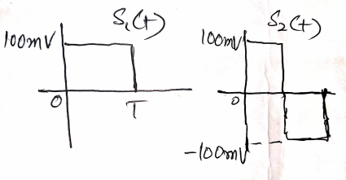

1. Prove the formula for Probability of error with proper diagrams and explanations.